“áu” wave:

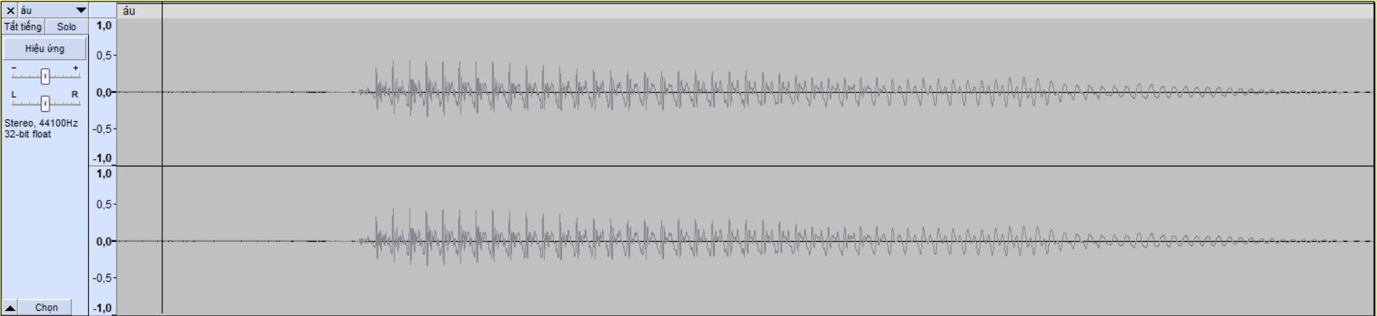

“áu” start:

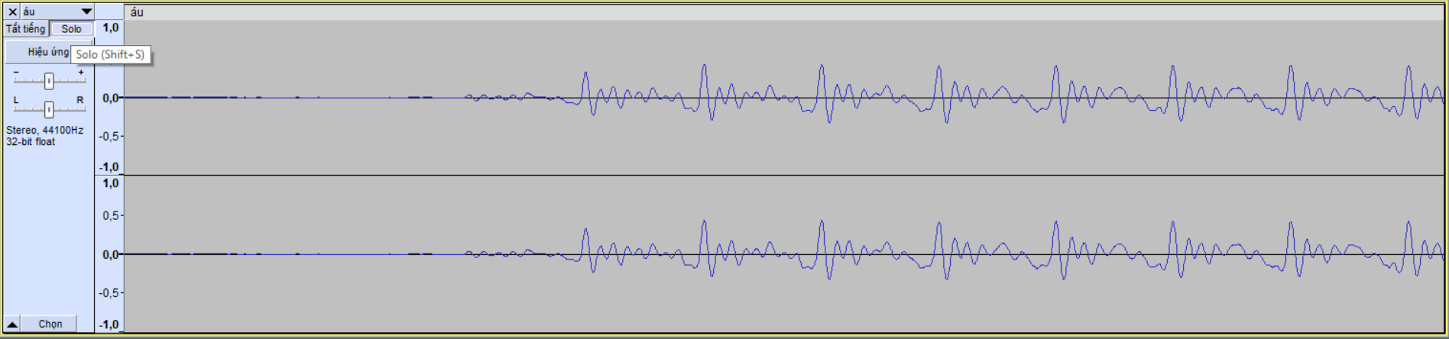

“máu: wave:

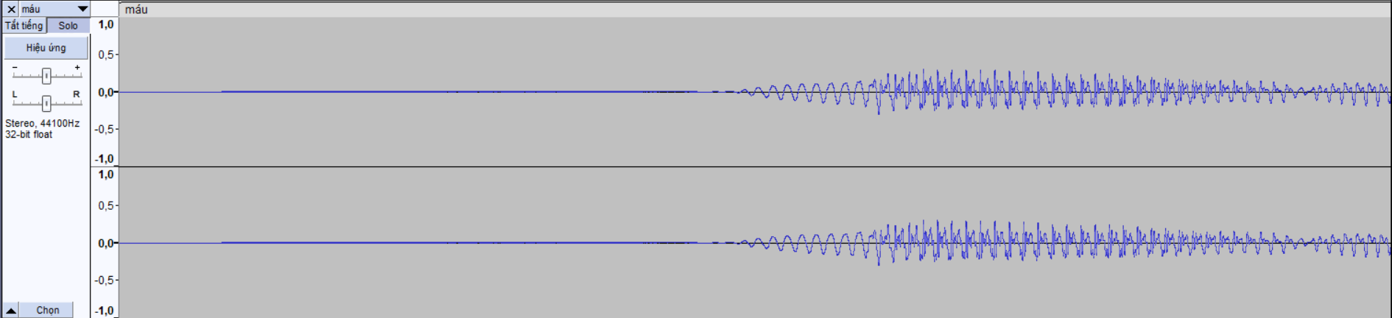

“máu” start:

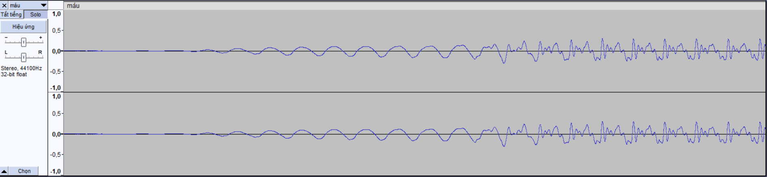

Compare “áu” mid and “máu” mid:

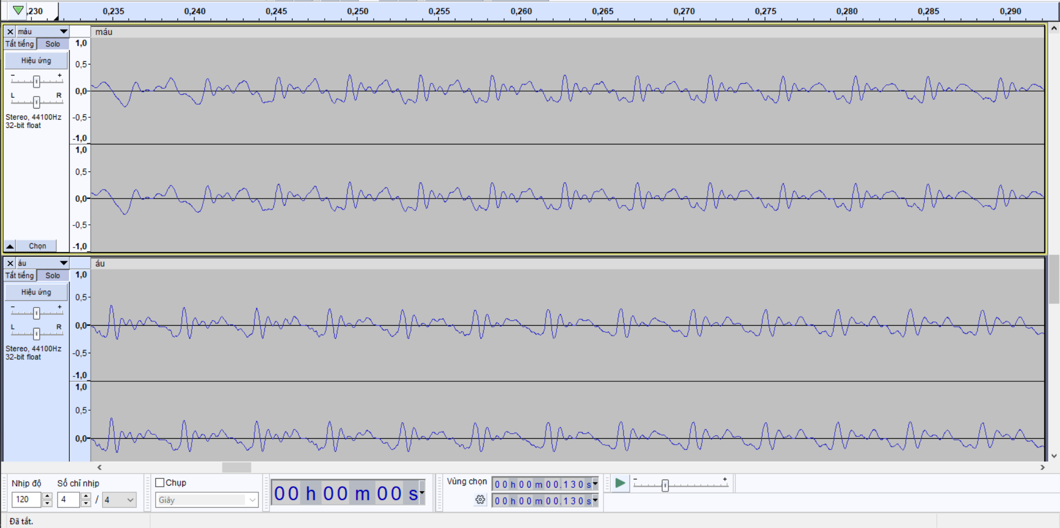

Towards the end, the waves of "máu" look more like "áu".

Let’s compare “máu” with “mê”:

“mê” wave:

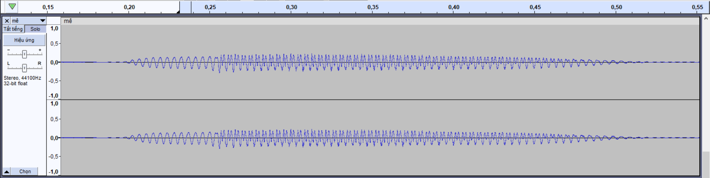

“mê” start:

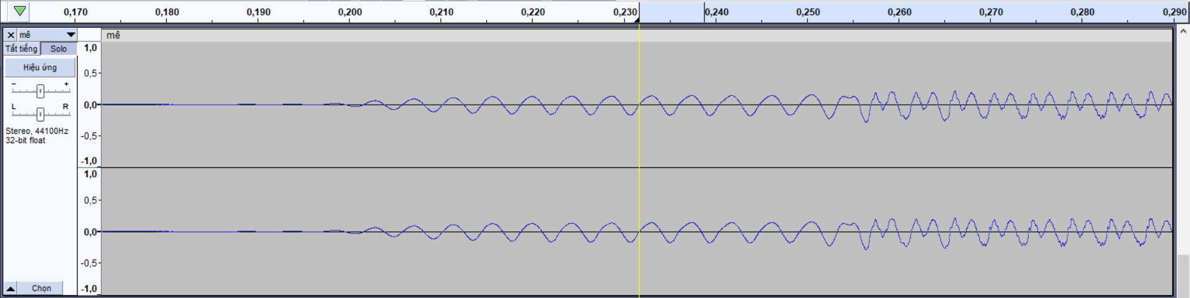

It’s like the start “mê” and “máu” are quite same. Is this a coincidence?

This is the way “cháu” start:

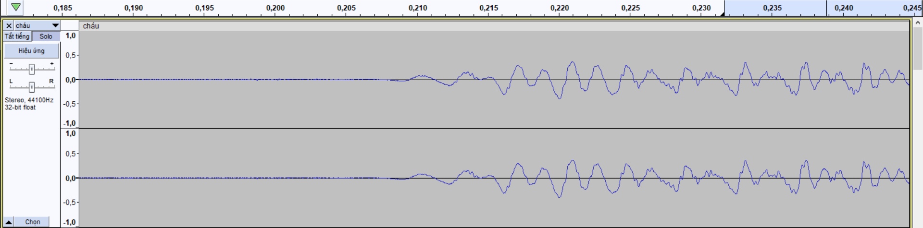

So it not coincidence.

This is the end of “máu” and “áu”, it’s quite same, this voice is create by “[Text to Speech ( TTS Free ) - TTSFree.com](https://ttsfree.com/)”, I think 80% the voice is from one people, so we could say that maybe “m” in “máu” effect on “áu” but not too much, same with “mê” and “ê”

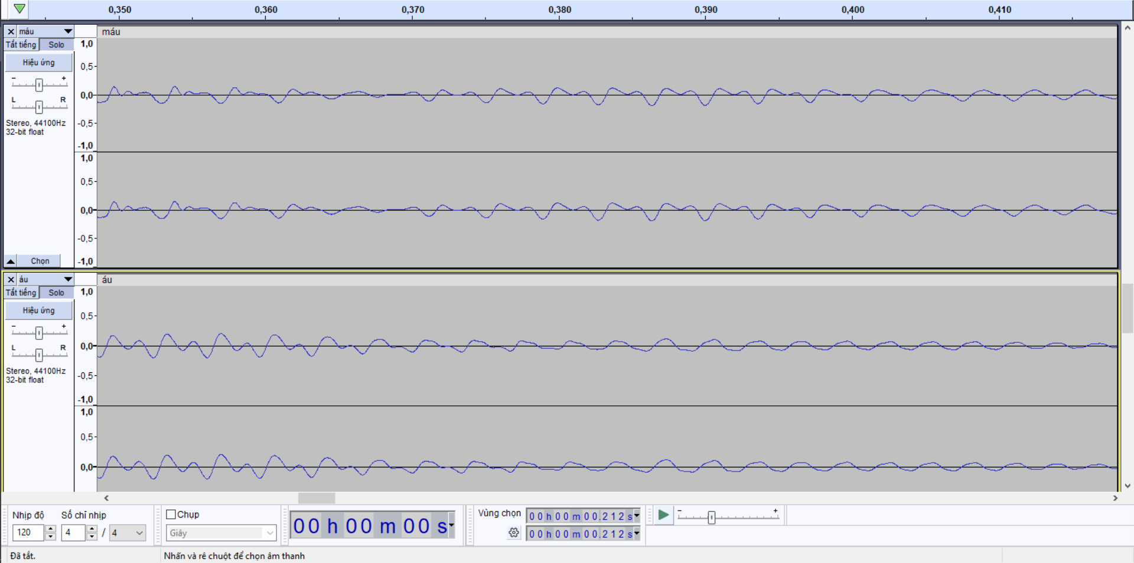

LET’S IGNORE THE EFFECT OF “M” IN “MÁU” ON “ÁU”, PROBLEM SOLVED :v

Well, no joke anymore, see the wave, we can know that “máu” is just combination of “m” and “áu”, the percent like: 0.75length(m): 0.25length(m)+0.25length(áu): 0.75length(áu)

The number is not perfect, but we can do this in future, I don’t think this is big problem, just add like math (or maybe not)

Anyway, do easy thing first OwO.